Troubleshooting for Solar skylights
- Contents of Box

- How to identify blind

- Installation
a. Installing fixing brackets
b. Fitting cassette
c. Handle centralisation
d. Feeding the belts
e. Inserting siderails
f. Tensioning the belts

- Replacing feet on siderails

- Replacing pips

- Blind Starting to step after 9 months

- Replacing battery

- Releasing the tension clip at the feet

- Contents of the box:
- Cassette
- Siderails
- Fitting screws
- Remote control
- Instructions
- Mounting corner brackets (when required- Keylite, Fakro & Roto windows)
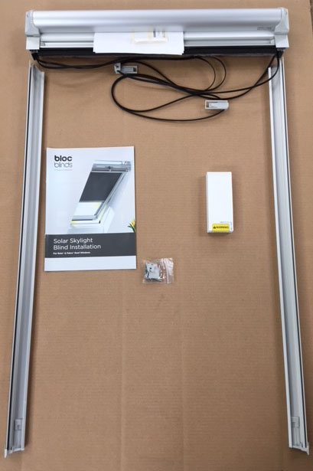

- How to identify blind
CUSTOMER ID LABEL
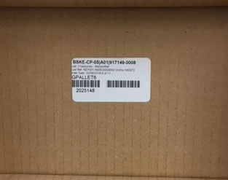
PLACED ON BACK OF CASSETTE, ON SIDERAILS AND
ALSO ON END OF DELIVERY BOX
- Installation
3a. Fitting of mounting corner brackets when required
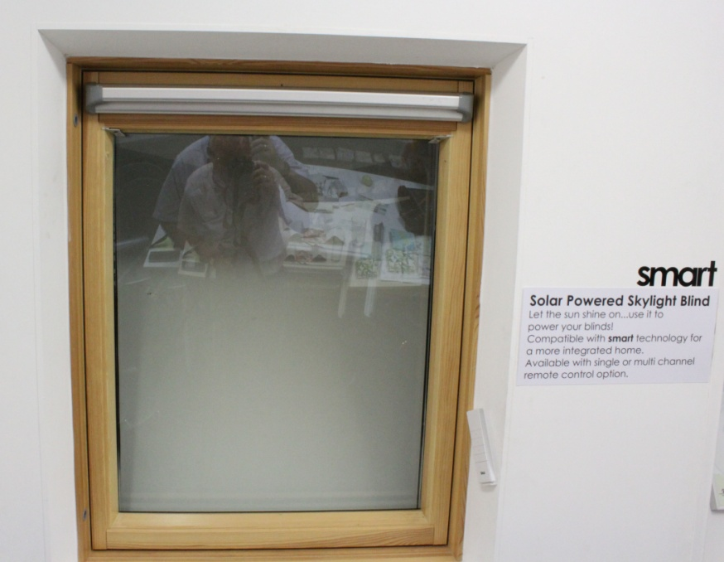

When fitting mounting brackets make sure that they are fitted flush into the top corners see photo below.

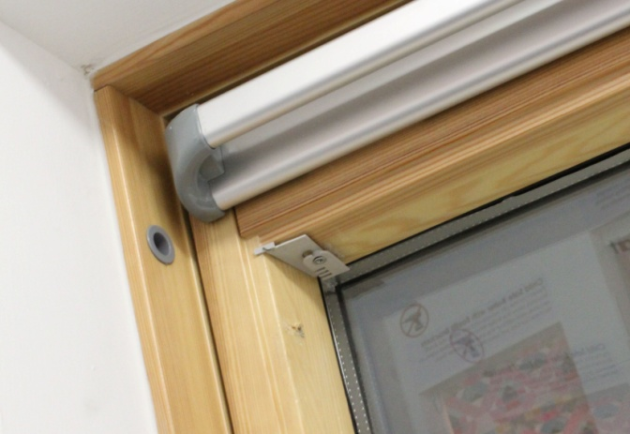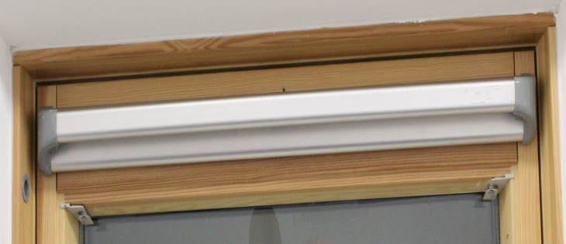

3b Fitting of cassette
If corner brackets have been fitted align cassette to slide onto them, then press firmly into the window recess. Make sure that cassette is firmly against the window frame (see photos below). If the brackets are not required then follow the fitting instructions

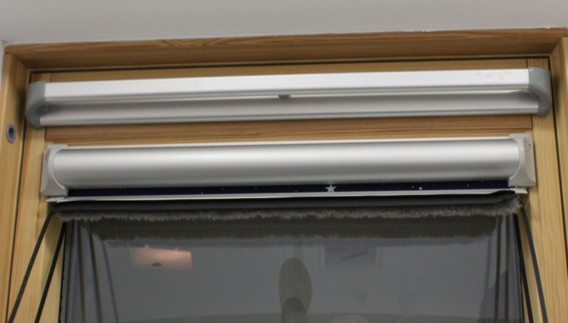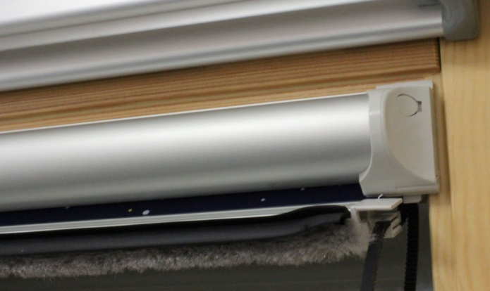
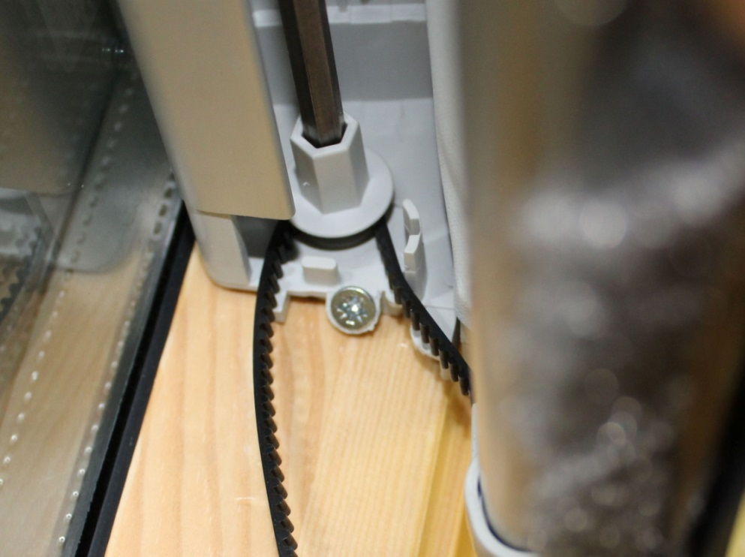
When fitting the cassette screws make sure that they’re flush with cassette ends (see photo below), and not protruding.

3c. Checking to see if handle is centred on the fabric
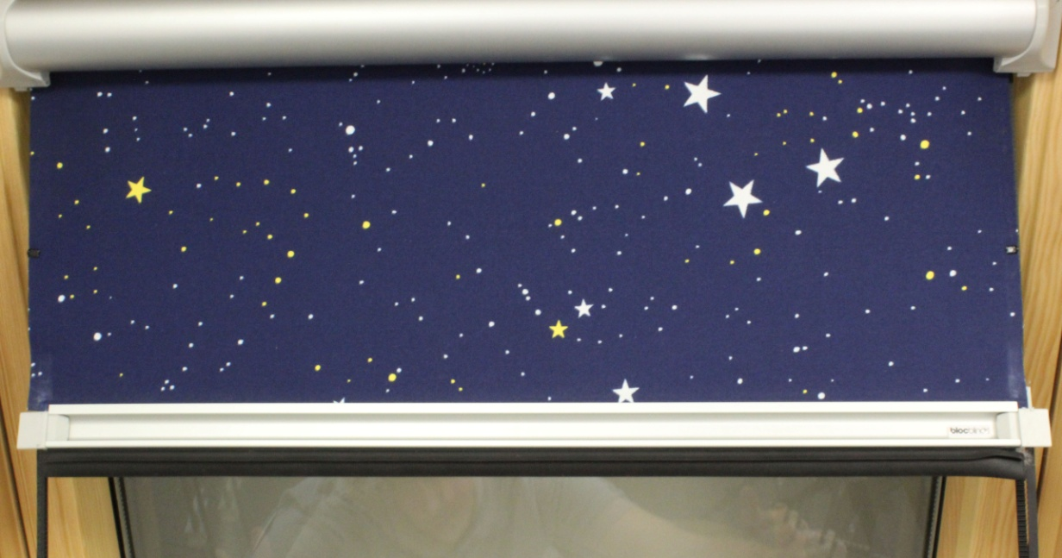
Incorrect
Slide the handle over until the fabric is equal on both sides, see below.
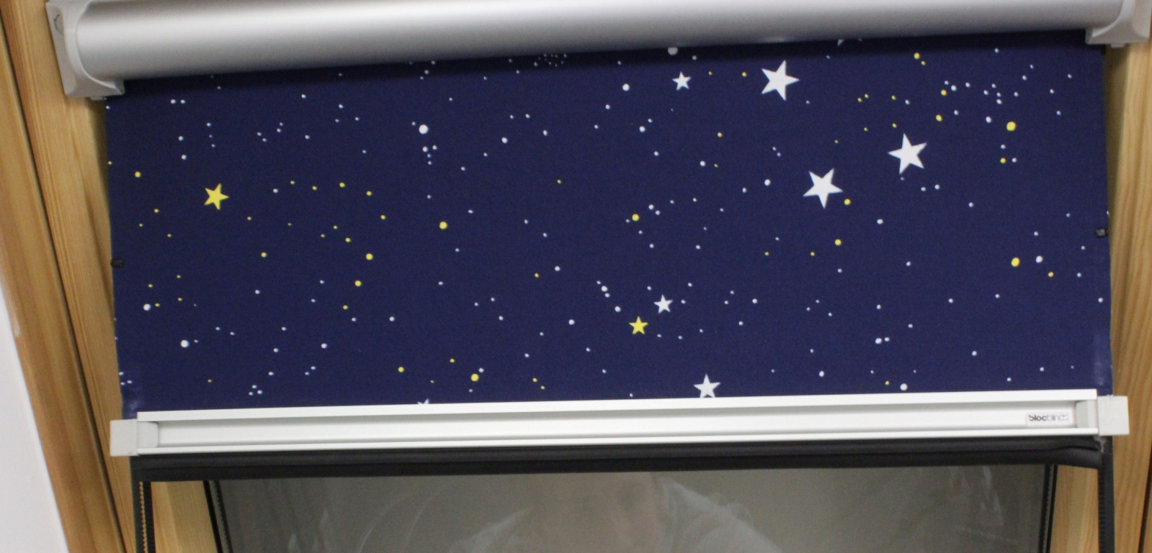
Correct
3d. Feeding tensioned clip and belt into siderail
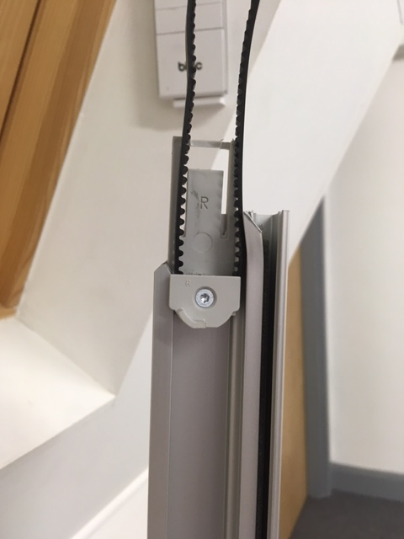
Make sure the clip is inserted correctly into the siderail channel. Also check to see that there is no twisting on the belt.

3e. Inserting Siderails
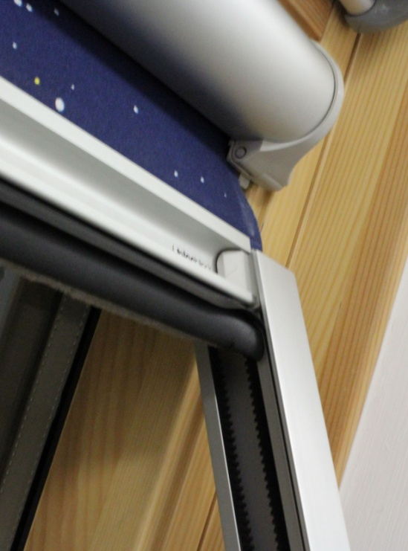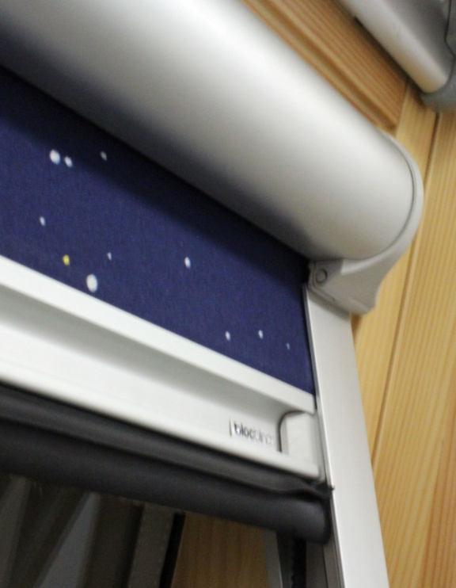
Slide side-rail through handle end and slide up and insert under cassette end.

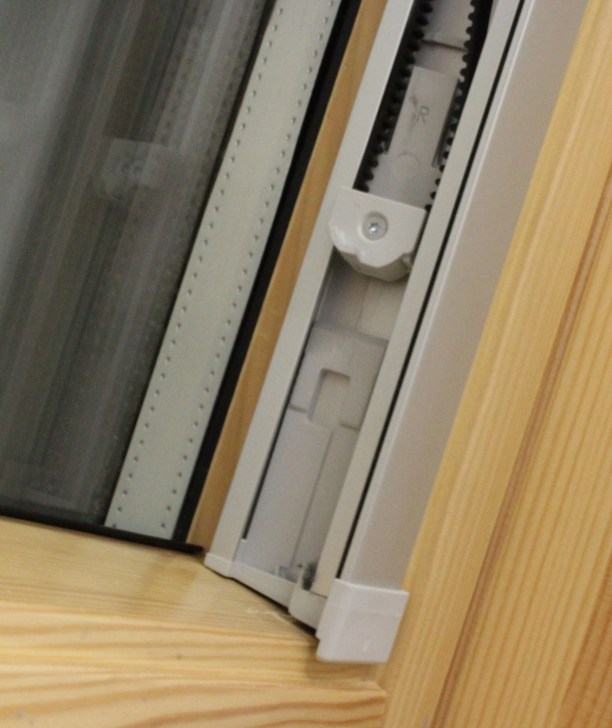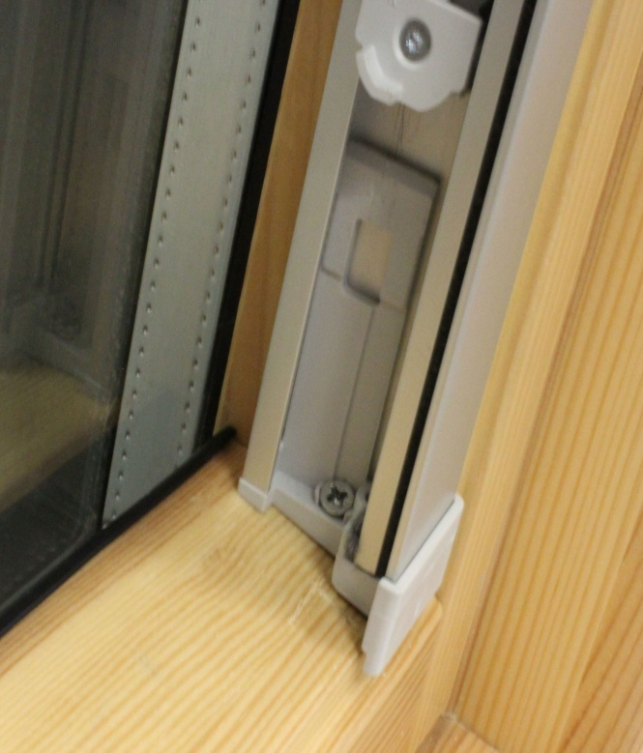
Make sure siderails are fitted firmly into the sash recess and the front face of the siderail is flush with the front of the frame. Make sure that the screw head is not protruding up as this does not allow the tensioned clip, not to click in correctly.
3f. Tensioning Belts
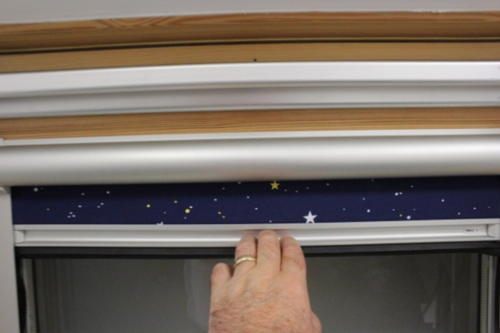
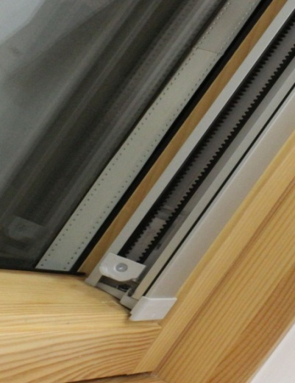
Hold handle in the centre and pull down to remove slackness on the belts. Press down on the tension clip until it clicks in; repeat this on the opposite side as well.

- Replacing foot on the siderails
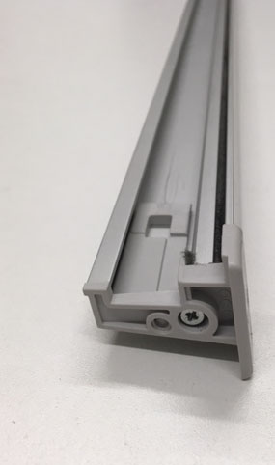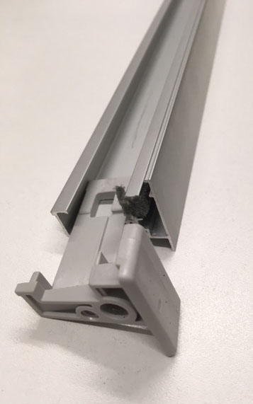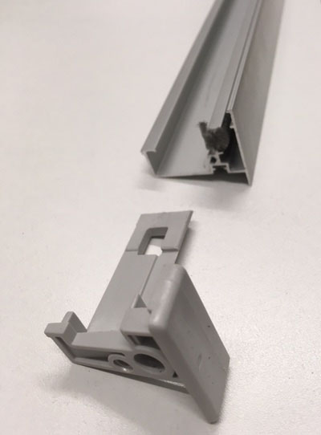
Take screw out, slide the foot off and replace with sliding the new one into position, then return screw.

- Replacing missing pips
Missing pip
Plastic pip
Insert pip stud through the hole, fold over and clip closed
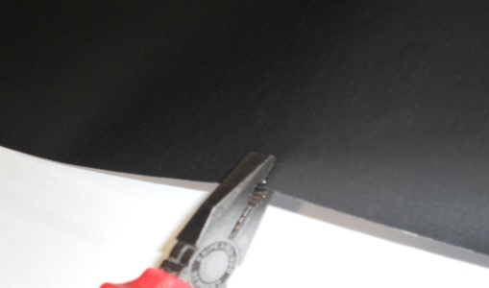
Insert pressure with pliers and crimp flat surface of the pip

- If blind starts to step after 9 months
If the operation of the blind starts to step or slow down when pressing the remote it may be caused by a couple of issues.
- Solar not charging battery
- Battery not taking the charge
Or
- It may be where the window is positioned i.e. under obstacles such as high trees blocking substantial light charging the battery especially in winter months, less daylight.
- Over-hanging branches
- High rise buildings, either on the left or right or in front of the window.
Then it may better to replace the battery first to see if this gets the blind operating again and then look at issues above to see why the battery is not charging.

- Replacing battery
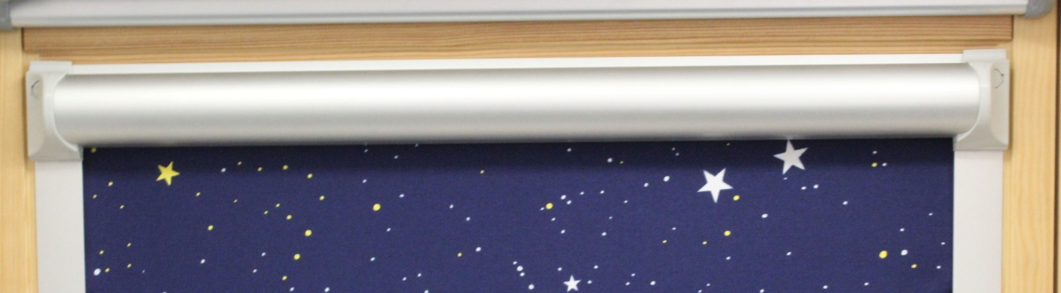
Push in buttons on either side of the cassette to open front
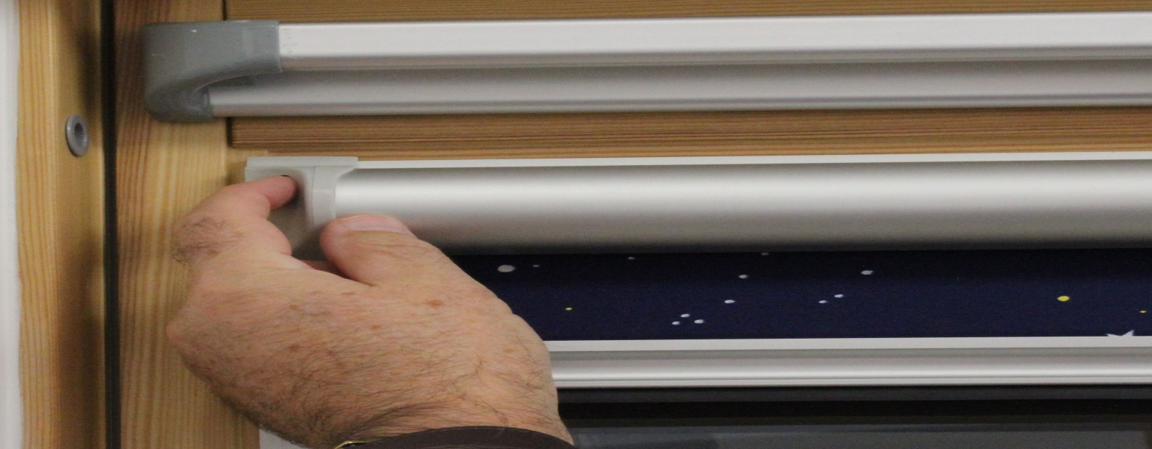
The front will fall forward from the top; the cover is hinged at the bottom and will not fall off.
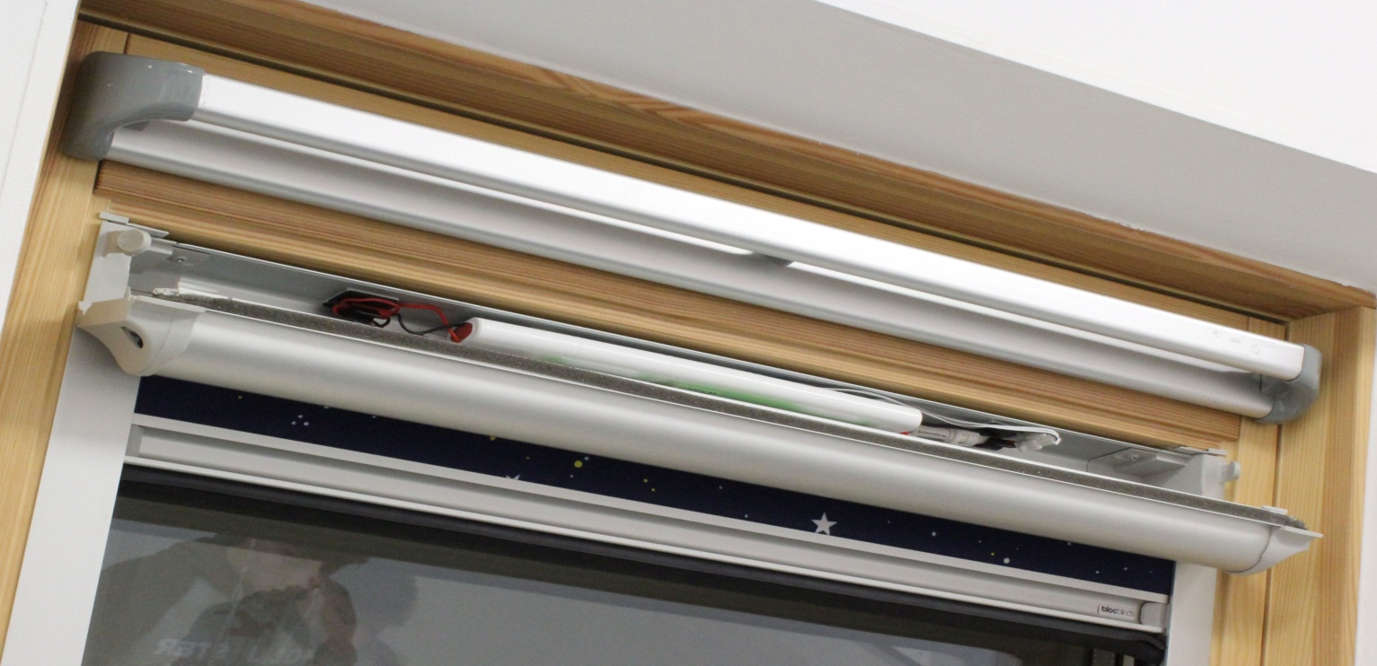
Remove connecting cables from their clips.
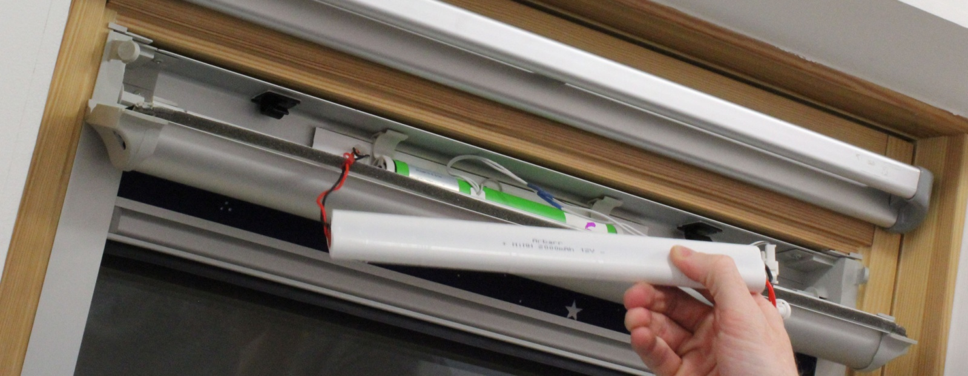
Remove battery from housing.
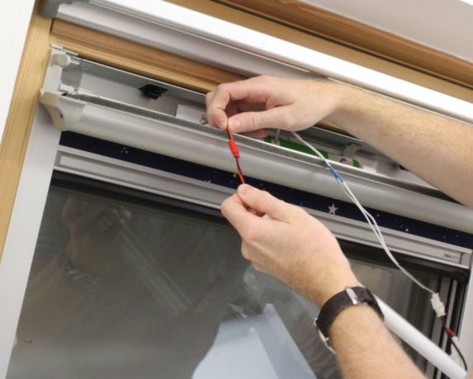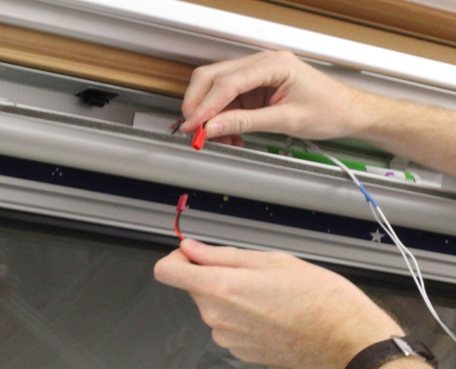
Pull connection apart from solar panel to battery pack.
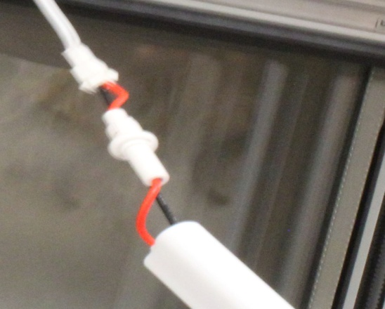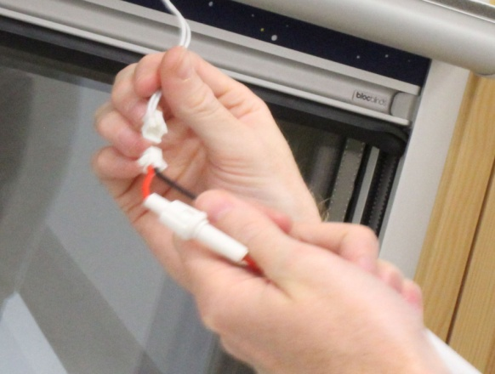
Pull connection apart from battery pack to battery.
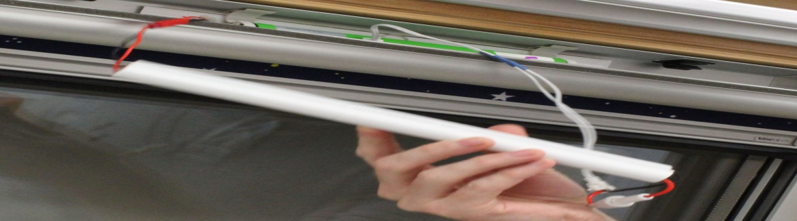
Connect new battery pack and return to housing
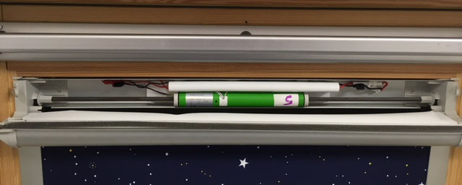
Make sure that all cables are clipped in correctly into the holders and that no cables are resting on or near the hexagon bar.
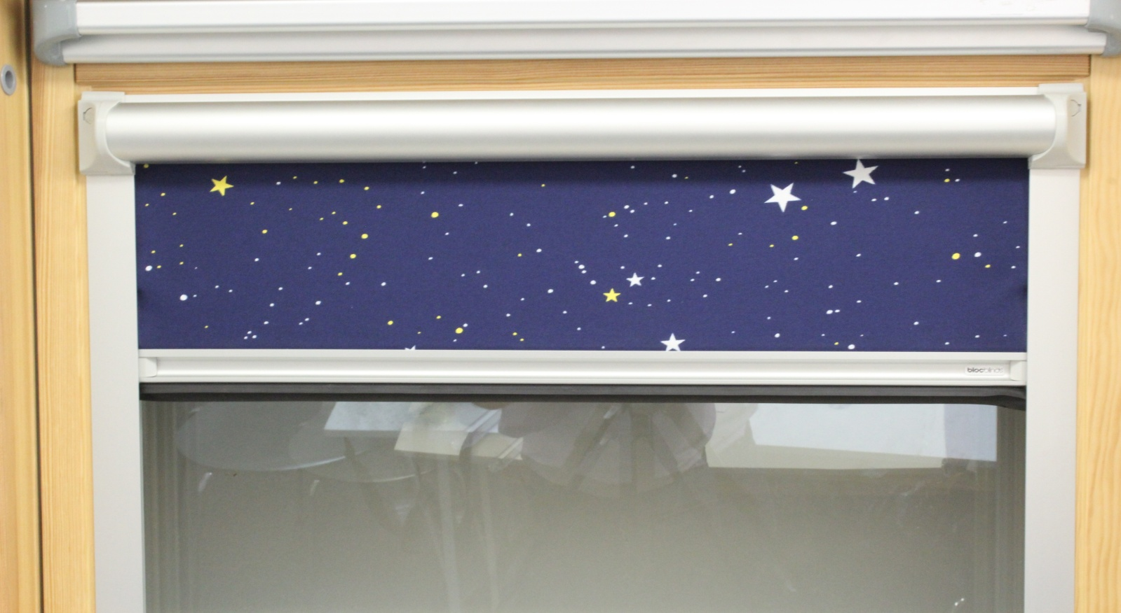
Closed cover before operating the remote control.
- Releasing the tension clip

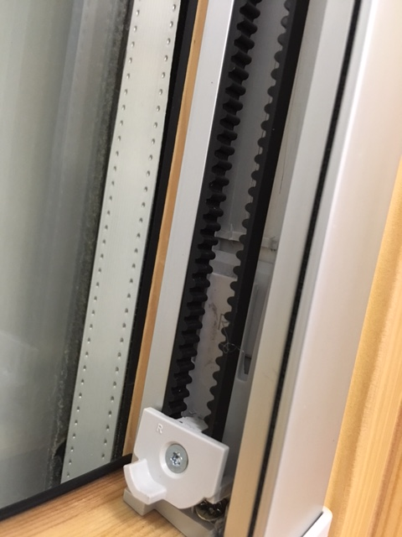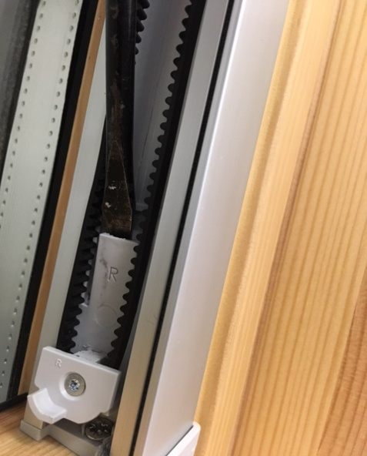
When releasing the clip use a flat head screwdriver slip it in between the tension clip and the back of the foot. Prise slightly forward and the clip it is released.
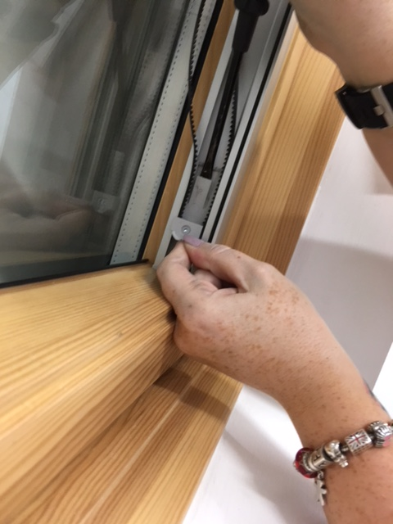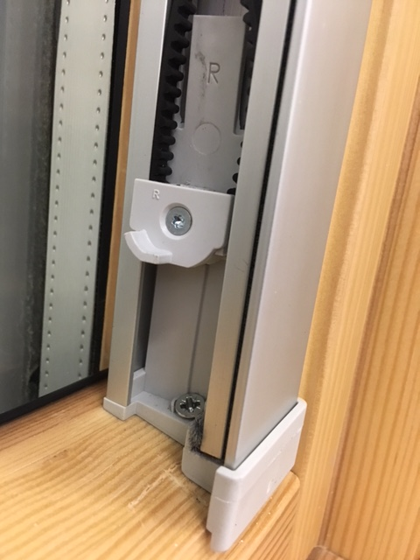
Slide clip upwards then clip is released

