Re-tensioning a Skye Blind for reducing puckering
- Identify which side needs to be adjusted. For example, with puckering on right-hand side, the right-hand cord can be tightened, or the left-hand cord can be loosened. The reverse is the case for left-hand puckering.
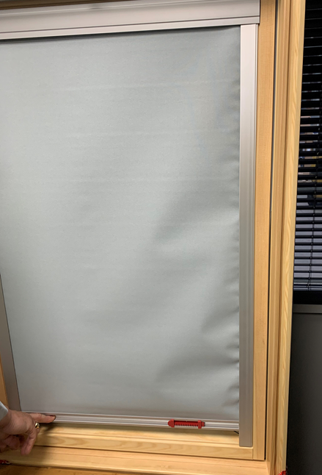

Tighten
Loosen

- Remove end of cord from bottom corner of the frame.
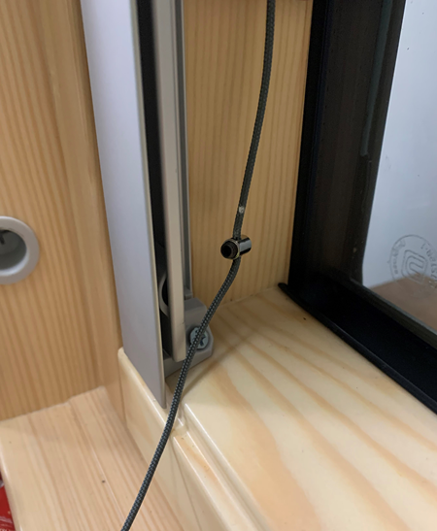
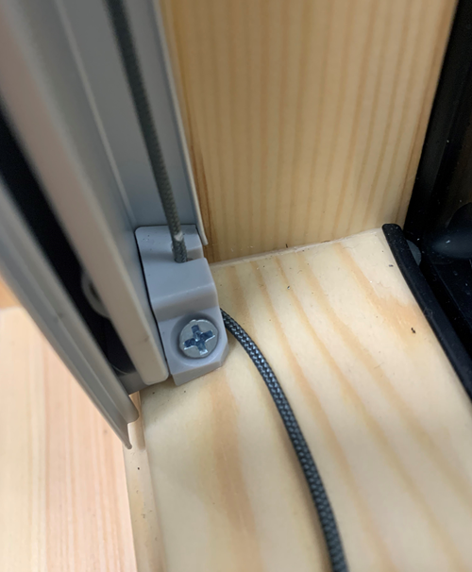

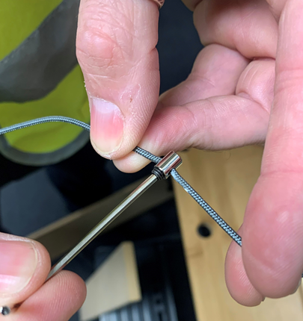
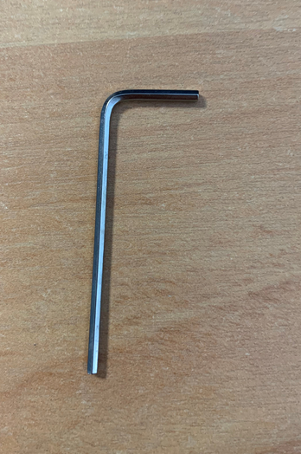
- Use Allen key (included in bag with mounting screws) to loosen the screw in the cord stopper.

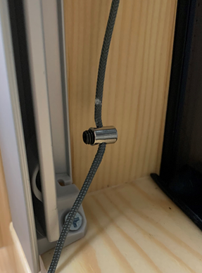
- Move stopper up to tighten or down to loosen and re-tighten the screw to keep it in place.
Tighten
Loosen

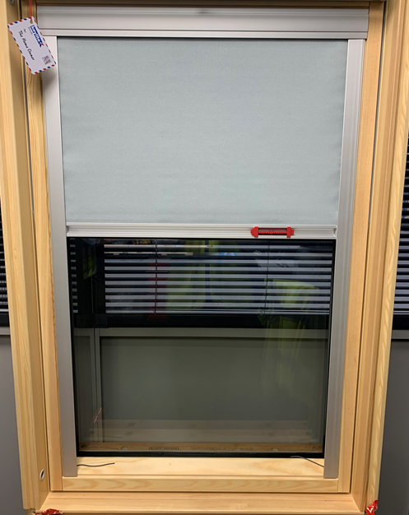
- Put cord back in corner and re-check blind for puckering. Repeat process until both sides look even.

